SQL - (DQL: Data Query Language)

How an user interacts with a management system and how a user writes queries.

Query planner: take the user query, transform it in a sequence of operations (of relational algebra) to execute in a database.

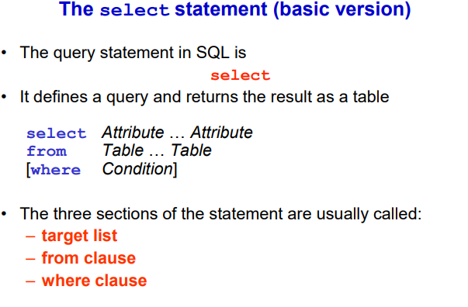

Every DQL (aka query) in SQL starts with select.

We usually have three elements
- One start with select
- Then from (is optimal)
- Then Where (is optional)

To read query in proper way: start form the from, then read where, then go to select

From clause: specify the list of tables (with [] is the cartesian product of linear algebra)
Where clause: filter the table obtain from the cartesian product according to a condition (aka select the rows that we want to keep)
Target list (select): specify which columns of the result we want to keep

Most basic form of query: Cartesian product → selection → projection (aka a joint with a projection)

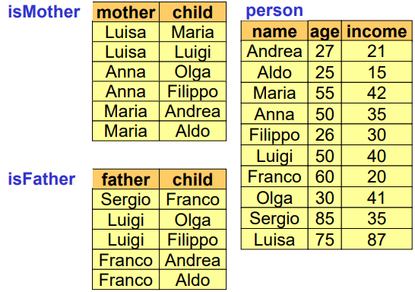

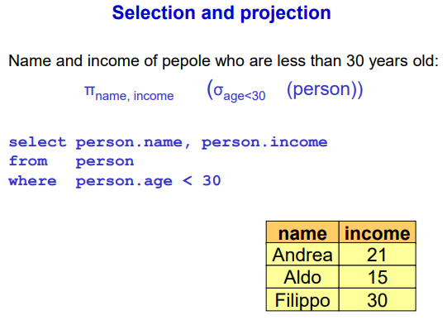
We want to know the name and income of people who are less than 30 years old.

- Understand from which table we need to work (aka person table, it contains both name and age)

NOTE: it would remove duplicates
NOTE: read from the from

select person.name, person.income 3) project only the columns name and income
from person 1) from the table person
where person.age < 30 2) keep the tuples where the age is less than 30

NOTE: if you have only one table in the from clause it collapses to the table itself, but if you have multiple tables it becomes the cartesian product
NOTE: whatever happens after from you will get a table to work with (either the table itself or the cartesian product)

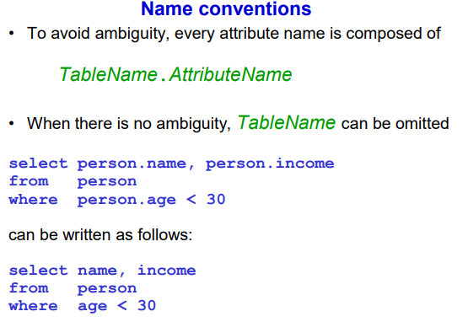
To avoid ambiguity can specify the table name (if it happens that multiple tables share the same column names).

So we could convert the old query to
select name, income
from person
where age < 30

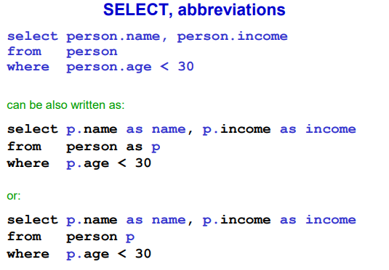
Sometimes the table names are very long and can be abbreviated.
select p.name as name, p.income as income ⟹ we can give also new names to the columns
from person p ⟹ we give a temporarily name to the table p
where p.age < 30

NOTE: columns name cannot have spaces

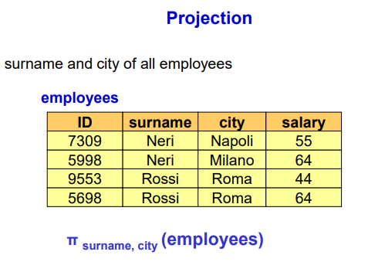
We want surname and city of all employees
NOTE: we will not have Rossi, Roma twice

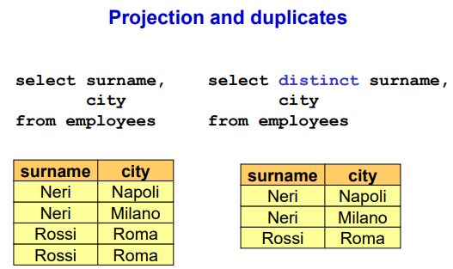

Removing duplicates is a very long task. By default SQL does not use set semantics ⟹ keep relations as sets and sets can not have duplicates.

SQL use bag semantics ⟹ allows duplicates (to avoid costly operation to remove duplicates).

To avoid duplicates we can use in sql
select distinct surname, city
from employees

NOTE: for large entity set can be very expensive

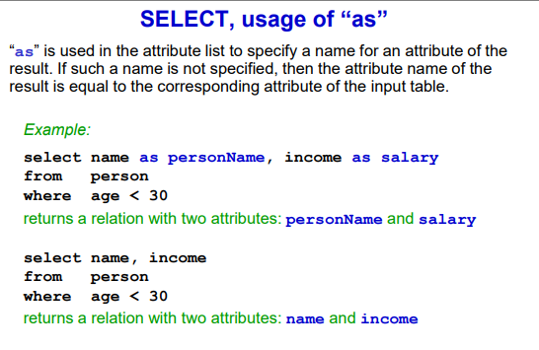
as keyboard is used to change attribute names. If you do not specify the new name with as it will keep the original name

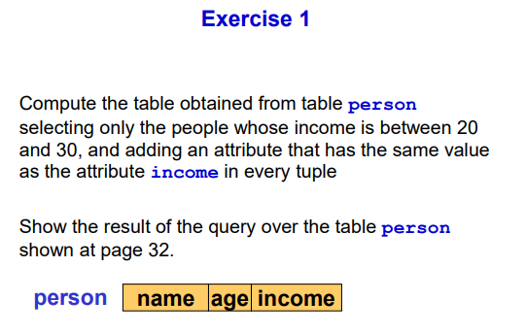
NOTE: we do not need to know the content, we just need to know the schema.

select people, income, income as repeatedIncome
from person
where income>=20 and income<=30

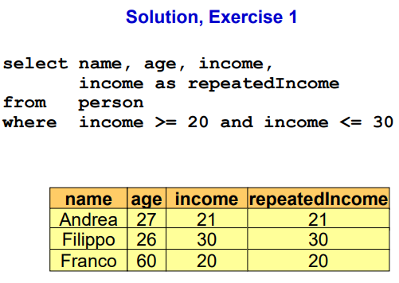

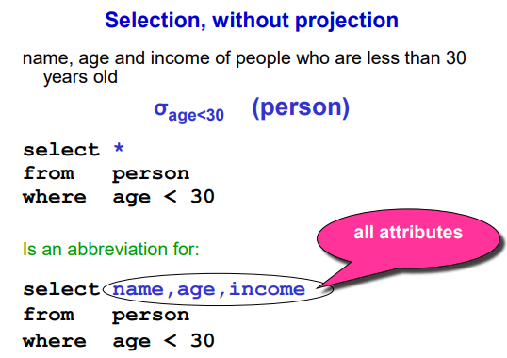

Sometimes you want everything from the table ⟹ use * and it will output every column

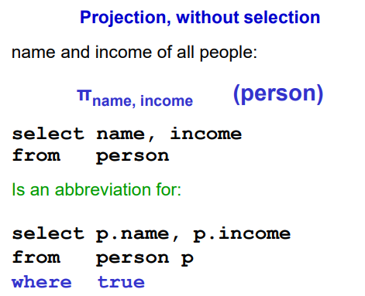
Without the where condition it just project the table (or the cartesian product of two or more tables)

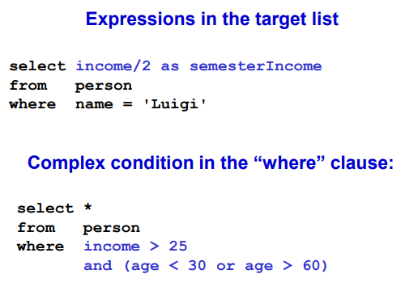
We can apply operations to the attribute in select for a final modification (in the select).

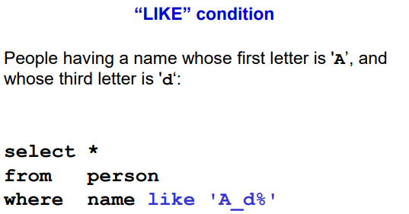
like operator let you match a string with a condition. Instead of saying the name is Andrea we can say tuples where the name starts with A.

_ ⟹ any character
% ⟹ arbitrary long string (even empty)

We say that the name should have:
- Letter A as first letter
- Whatever character
- Letter d
- An arbitrary long sequence of characters

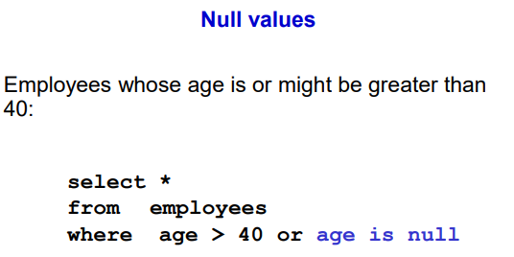
In real word we allow null.

Null ⟹ unknown values.

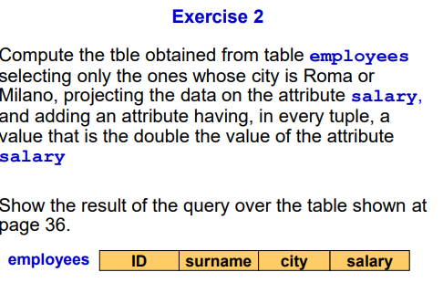
select salary as salary, 2 * salary as double_salary
from employees
where city is Roma or city is Milano city = ‘Milano’ or city = ‘Roma’

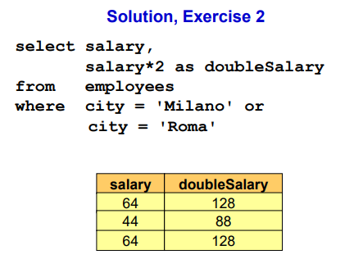

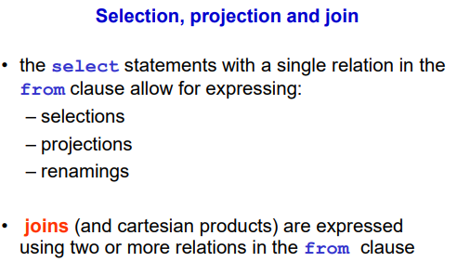

Joint operation can be implemented with cartesian product and condition selection.

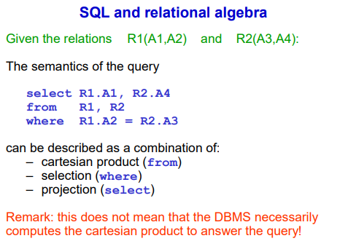
Cartesian product with two table ⟹ in the from clause put the tables to join

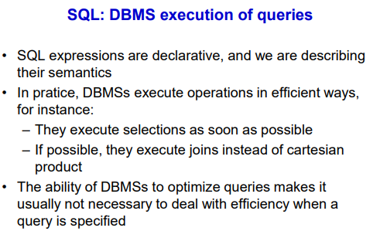
SQL query is declarative, the structure is always the same (select, from, where)

DBMS convert the query in a sequence of operation and try to do selection as soon as possible and to avoid do the cartesian product but to the joint on the fly

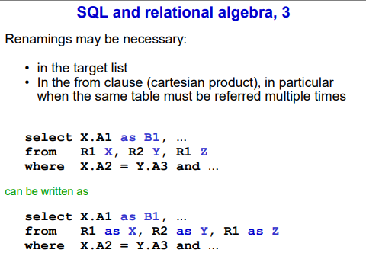

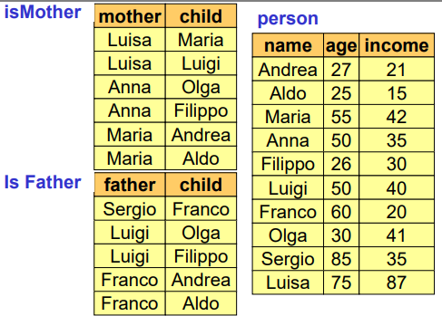

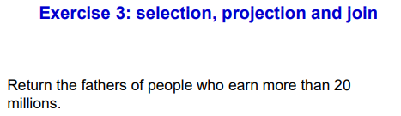

select distinct isFather.father
from person, isFather
where isFather.child = person.name and person.income > 20

NOTE: use distinct to avoid duplicates (luigi have two children that earn more than 20 million)

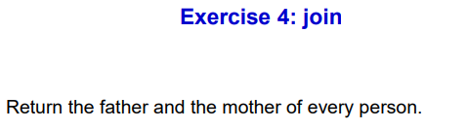
select distinct person, isMother.mother as Mother, isFather.father as Father
from isMother, isFather, person
where person.name = isFather.child or person.name = isMother.child

NOTE: we decide that we must store only individuals that have both mother and father in the database

select M.child, M.mother, F.father
from isMother M, isFather F
where M.child = F.child

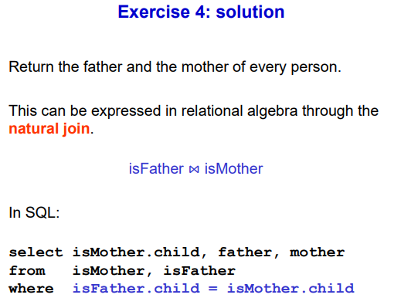

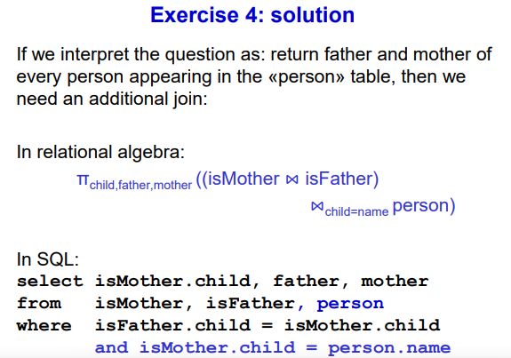

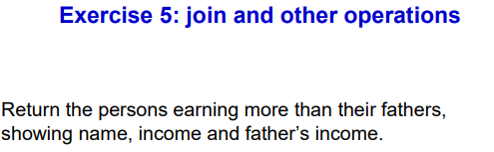
select P.name, P.income, K.income
from person P, isFather F, person K
where F.child = P.name and F.father = K.name and P.income > K.income

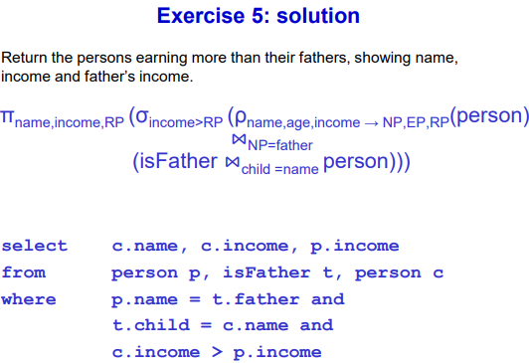

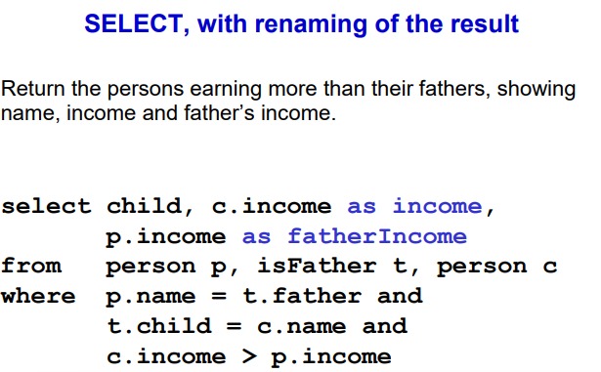

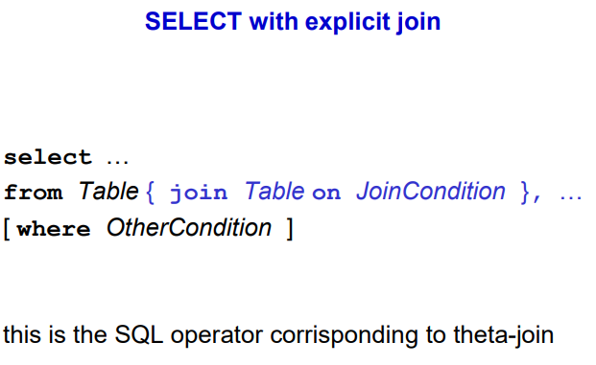
Sometimes in the where condition there are too many conditions. There is an additional syntax.

Use in the from a joint between two tables with a condition.

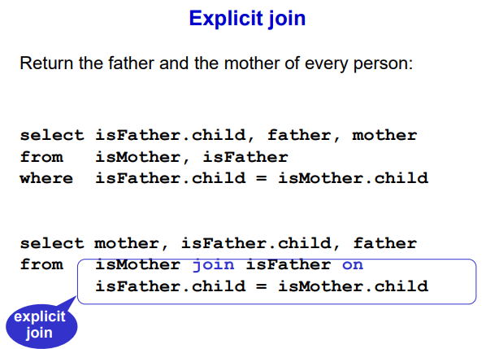
We can directly write in the from the condition.

(example below)

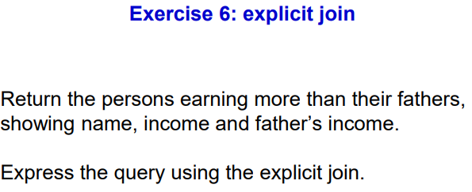

OLD
select P.name, P.income, K.income
from person P, isFather F, person K
where F.child =P.name and F.name = K.name where F.income > K.income

EXPLICIT JOIN
select P.name, P.income, K.income
from person P join isFather F on F.child = P.name join person K on isFather.name = K.name
where P.income > K.income

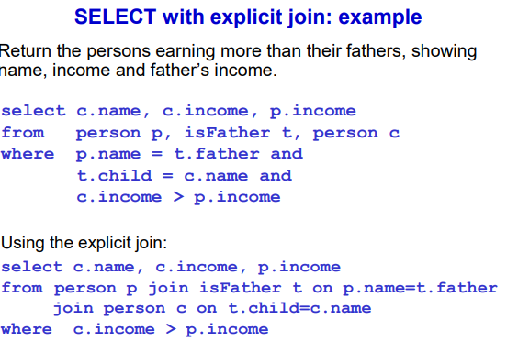

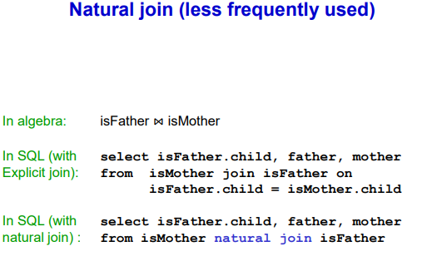
can also do on natural join

